Book

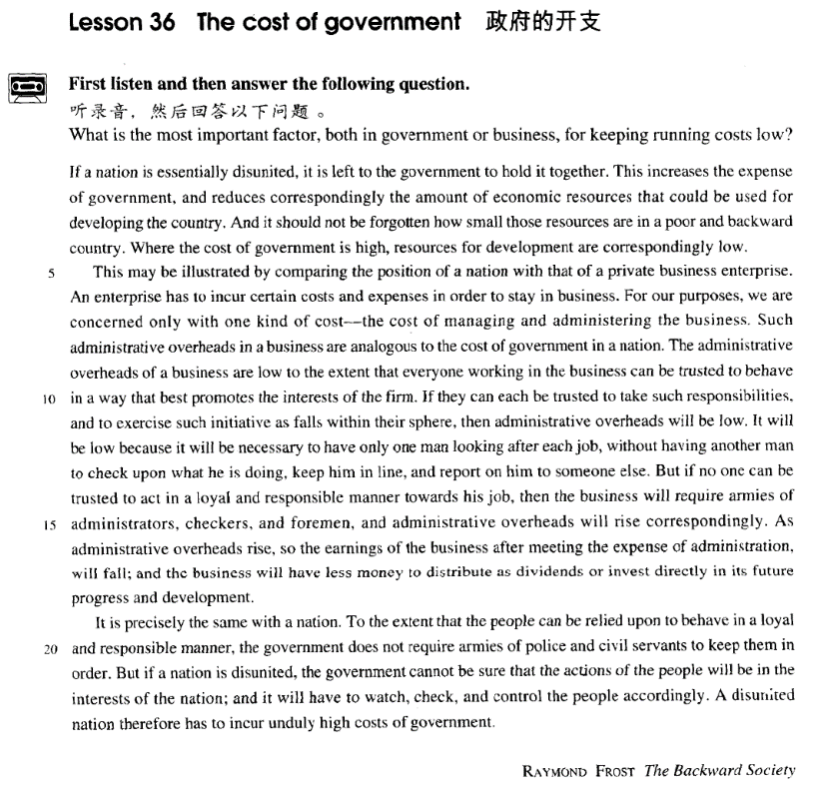

课文

If a nation is essentialy disunited, it is left to the government to hold it together.

如果一个国家实际上处于分裂状态，使之联合起来就是政府的事了。

This increases the expense of government, and reduces correspondingly the amount of economic resources that could be used for developing the country.

这样的一来就增加了政府的开支，从而相应地减少了可以用来了展国家的那部分经济资源。

And it should not be forgotten how small those resources are in a poor and backward country.

不应忘记，在一个贫穷落后的国家里，那部分财力是很有限的。

Where the cost of government is high, resources for development are correspondingly low.

凡是政府管理费用高的地方，用于发展国家经济的资金就会相应地减少。

This may be illustrated by comparing the position of a nation with that of a private business enterprise.

把国家的状况同私人企业的状况加以比较，就可以看清这个问题。

An enterprise has to incur certain costs and expenses in order to stay in business.

一个企业为了继续经营，不得不支出一定的费用和开销。

For our purposes, we are concerned only with one kind of cost -- the cost of managing and administering the business.

就我们的目的而言，我们只关心一种费用 -- 企业行政管理费。

Such administrative overheads in a business are analogous to the cost of government in a nation.

一家企业的行政管理开支类似于一个国家的政府管理所用的开支。

The administrative overheads of a business are low to the extent that everyone working in the business can be trusted to behave in a way that best promotes the interests of the firm.

如果企业中的每个人都在真诚地为提高企业利润而工作，那么企业的管理费用就会降低到相应的程度。

If they can each be trusted to take such responsibilities,

如果企业的每个人都信得过，人人都认真负责，

and to exercise such initiative as falls within their sphere, then administrative overheads will be low.

在各自的工作范围内发挥主动性，行政管理费用就会降低。

It will be low because it will be necessary to have only one man looking after each job without having another man to check upon what he is doing, keep him in line, and report on him to someone else.

行政管理费用的降低的原因是：每项工作只需要一个人去完成，用不着另外再有一个人检查工作。督促他遵守章程，或向有关人士汇报他的工作。

But if no one can be trusted to act in a loyal and responsible manner towards his job, then the business will require armies of administrators, checkers and foremen and administrative overheads will rise correspondingly.

但是，如果企业中谁也不可信赖会对工作尽忠守职，那公企业就会需大批的管理人员、检查人员和带班人员，管理费用就会相应在增加。

As administrative overheads rise, so the earnings of the business after meeting the expense of administration, will fall;

管理费用增加了，那么在扣除管理费用后，企业的收入就降低了。

and the business will have less money to distribute as dividends or invest directly in its future progress and development.

因此用于分红的金额就用于将来开拓和发展的投资就相应地减少了。

It is precisely the same with a nation.

一个国家的情况也完全相同。

To the extent that the people can be relied on to behave in a loyal and responsible manner,

如果人民忠于职守，举止规矩，能受到政府的信赖，

the government does not require armies of police and civil servants to keep them in order.

那么政府就不需要大批的警察和文职人员运去促使人民遵纪守法。

But if a nation is disunited, the government cannot be sure that the actions of the people will be in the interests of the nation; and it will have to watch, check, and control the people accordingly.

但是，如果一个国家处于分裂状态，政府不能相信人民的行动有利于国家，那么政府就不得不对人民进行监督、检查和控制。

A disunited nation therefore has to incur unduly high costs of government.

因此，一个处于分裂的国家必须要支付过高的行政管理费用。

词汇讲解

**Lesson 36 The cost of government** correspondingly [7kɔrə'spɑndɪŋli] adv. 相应地，从而，因此

corresponding adj. similar, or resulting from something else 类似的，相

应的

Company losses were 50 per cent worse than in the corresponding period last year.

As the course becomes more difficult, there's usually a corresponding drop in attendance.

correspondingly adv. 相应地，从而，因此

The cost of living in the city is more expensive, but salaries are supposed to be correspondingly higher.

correspond v. 1. to be the same as or match sth. 相一致，相符合

Your account and hers correspond. correspond with / to …

Your account of events corresponds with / to hers.

correspond v. 2. to be similar to or the same as sth else 相当于

correspond to …

The American Congress corresponds to the British Parliament.

The British job of Lecturer corresponds roughly to the US Associate Professor.

correspond v. 3. exchange letters 通信

They have corresponded regularly for years. correspond with …

I've been corresponding with several experts in the field.

correspondence n. 1. [C] a strong connection between two things 紧密联系

There is a definite correspondence between infant mortality and poverty. correspondence n. 2. [U or singular] the process of writing and receiving letters 通信

I refused to enter into any correspondence with him about it.

We kept up a correspondence for many years.

correspondence n. [U] the letters that someone sends and receives 某 人的信件

A secretary came in twice a week to deal with his correspondence.

There is nothing secretive about the Ombudsman's work, for his correspondence is open to public inspection.

incur [ɪn'kɜ:(r)]

v. 蒙受经济损失，不得不支付； 招致，招惹

incur v. 1. if you incur costs, you have to pay them 蒙受经济损失，不得不支付

incur costs / losses / debts etc.

The company has incurred huge losses over the past three years.

An enterprise has to incur certain costs and expenses in order to stay in business.

incur v. 2. if you incur sth. unpleasant, it happens to you because of sth. you have done 招致，招惹

Each stage of the process incurs an additional risk.

incur sb’s displeasure / wrath etc.

She wondered what she'd done to incur his displeasure this time.

She had incurred the wrath of her father by marrying without his consent. occur v. 发生

When exactly did the incident occur?

Something unexpected occurred. concur v. 同意；同时发生

We strongly concur *with* the recommendations of this report.

Everything concurred to produce the desired effect. recur v. 再次发生，反复发生

We must make sure that the problem does not recur.

a recurring illness / nightmare

The same old favourites recur year in year out with monotonous regularity.

administer [əd'mɪnɪstə(r)]

v. 管理；给予，施以

administer v. 1. to manage the work or money of a company or organization 管理

to administer a charity / fund / school

The pension funds are administered by commercial banks.

The plan calls for the UN to administer the country until elections can be held.

administer v. 2. (fml.) to cause sb. to receive sth. 给予，施以

to administer medicine / punishment / relief

The test was administered to all 11-year-olds. administrator n. [C] 管理人员，行政人员administrative adj. 管理的，行政的administrative staff / duties / job / costs

administration n. 1. [U] 管理

She has little experience in administration. administration n. 2. [C]（尤指美国）政府

This happened frequently during the Nixon Administration.

administration n. 3. [U] 给予，施以

the administration of justice the administration of sedatives analogous [ə'næləgəs]

adj. 类似的

analogous adj. (fml.) similar in some way to another thing or situation and therefore able to be compared with it 类似的

The two processes are not analogous.

be analogous to / with …

Sleep has often been thought of as being in some way analogous to death. The present crisis is analogous with the situation immediately before the war.

analogy n. sth. that seems similar between two situations, processes etc.

类似

draw / make an analogy = make

a comparison

He drew an analogy between the brain and a vast computer. initiative [ɪ'nɪʃətɪv]

n. 积极性，主动性；主动权

initiative n. [U] the ability to make decisions and take action without waiting for someone to tell you what to do 积极性，主动性

a man who lacks the initiative to be a leader

I wish my son would show more initiative.

the initiative [sing] power or right to take action 主动权

The initiative has passed to us.

Because of the general's indecisiveness, our armies have lost the initiative

to the enemy.

It was up to the US to take the initiative in repairing relations. “it” = to go

initial “in” = into adj. 最初的；n. 姓名首字母；v. 签姓名首字母

initiate v. 发起，创始；接纳……为新成员

initiation n. 发起，创始；入会

initiator n. 发起人，创始者

initiative n. 积极性，主动性；主动权

itinerary n. 行程，旅行计划

circuit “circu” = round n. 环行线，周线；电路

circuitous adj. 迂回的，曲折的transit “trans” = across n. 运输transition n. 过渡

transitional adj. 过渡性的

unduly [7ʌn'dju:li] adv. 过度地

unduly adv. more than is normal or reasonable = excessively 过度地

The levels of pollution in this area are unduly high. He did not sound unduly worried at the prospect.

We realized that they must have become unduly frightened by the rising flood, for their house, which had sound foundations, would have stood stoutly even if it had been almost submerged.

undue = excessive adj. 过度的

The work should be carried out without undue delay. We did not want to put any undue pressure on them.

And if this something else is rightly chosen, if it really attended by the illumination of another field of interest, gradually, and often quite swiftly, the old undue grip relaxes and the process of recuperation and repair begins.

due adj. 1. proper, suitable 适当的

After due consideration, we have decided to appoint Mr. Davis to the job. due adj. 2. expected to happen or arrive at a particular time 预期的，到时间的

When's the baby due?

The next train is due in five minutes. be due to do sth.

The strike is due to begin on Tuesday.

His new book is due to be published next year.

If a nation is essentially disunited, it is left to the government *to hold it*

*together*.

essentially adv. 1. used for emphasizing what is the most important aspect of sth. or fact about sth. 本质上，根本上

There are three essentially different ways of tackling the problem.

essentially adv. 2. used for saying that sth. is mostly true, but not

completely true 大体上，基本

The list is essentially complete.

His analysis of urban use of agricultural land has been proved essentially correct.

leave v. to let someone else decide sth. or be responsible for sth. 让某人

决定或负责某事

leave sth. to sb.

You can leave the cooking to me. I’ll leave it to you to buy the tickets.

hold sth. together: cause sth. to remain together, unite sth. 使……团结一

致

The country needs a leader who will hold the nation together. In those days the Church held the community together.

This increases the expense of government, and reduces correspondingly the amount of economic resources that could be used for developing the country.

Number is regularly used with count nouns <a large number of mistakes> while amount is mainly used with mass nouns <annual amount of rainfall>. The use of amount with count nouns has been frequently criticized; it usually occurs when the number of things is thought of as a mass or collection <glad to furnish any amount of black pebbles> or when money is involved <a substantial amount of loans>.

use sth. for (doing) sth.

They were using animals for scientific experiments.

And it should not be forgotten how small those resources are *in a poor*

*and backward country*.

backward adj. developing slowly and less successfully than most others

落后的

a backward child

It will take decades to bring this backward country into the modern age.

Where the cost of government is high, resources for development are correspondingly low.

This may be illustrated *by comparing the position of a nation with that of*

*a private business enterprise*.

illustrate v. to make the meaning of sth. clearer by using examples, pictures, etc. （用例子、图表等）说明，阐明

To illustrate my point, let me tell you a little story.

The lecturer illustrated his point with a diagram on the blackboard. be illustrated by …

Their properties could be illustrated by simple experiments.

The general restlessness and hurry of life are always illustrated by the practice of fast eating.

amply / clearly / dramatically / graphically / vividly illustrate …

One example may amply illustrate this point.

The example of the United States graphically illustrates this point.

The story of a poor family that acquired fame and fortune overnight, dramatically illustrates the power of the press.

illustration n. 1. 插图；2. 例证，例子

A recent article in a weekly newspaper, for instance, was headed with a striking illustration of a lady in a state of considerable distress, with the caption 'She was yet another victim, reduced to a screaming wreck'. compare … with / and …

to examine people or things to see how they are similar and how they are different

contrast … with / and …

to compare two things, ideas, people etc. to show how different they are from each other

position n. the situation that someone is in, especially when this affects what they can and cannot do 地位，处境，状况

in a / an *delicate / dominating / favorable / adverse* position

She’s in the enviable position of being able to choose who she works with.

When two of your best friends argue it puts you in a very awkward position.

Future historians will be in a unique position when they come to record

the history of our own times.

If you are younger, and in a solid financial position, you may decide to take an aggressive approach but only if you're blessed with a sanguine disposition and won't suffer sleepless nights over share prices.

Her tone was that of a parent to a disobedient child.

Some commentators compared his work with that of James Joyce.

His style could scarcely be further removed from that of his predecessor. Cockburn's arrival coincided with that of Sir Iain and Lady Noble.

An enterprise has to incur certain costs and expenses in order to stay in

business.

in business: A company that is in business is operating and trading.（公司） 经营，运转

The company has been in business for over thirty years. You can't stay in business without cash.

*For our purposes*, we are concerned only with one kind of cost ― the

cost of managing and administering the business.

purposes n. [pl.] what is needed in a particular situation 需要

for … purposes 出于……的需要

These gifts count as income for tax purposes.

For the purposes of this study, the three groups have been combined.

For the purposes of this book, America is taken to include the continent north of Mexico.

be concerned with sth.: be about sth. 与某事物有关，涉及某事物

Her latest documentary is concerned with youth unemployment. be concerned about / for sth.: be worried about sth. 为某事担忧We're all concerned about / for her safety.

Such administrative overheads in a business are analogous to the cost of government in a nation.

overheads n. [pl] regular expenses involved in running a business, e.g. rent, light, heating, salaries （企业运转所需要的）经费（如房租、电费、取暖费、薪金）

Heavy overheads reduced his profits.

be analogous to / with …

But these are not analogous to what happens when man ages.

The administrative overheads of a business are low to the extent that everyone working in the business can be trusted to behave in a way that

best promotes the interests of the firm. to the extent that … 1. 以至于……

Sales have fallen badly this year, to the extent that we will have to close

some of our shops.

Violence increased to the extent that residents were afraid to leave their homes.

to the extent that … 2. 只要……，只有……

To the extent that the people can be relied upon to behave in a loyal and

responsible manner, the government does not require armies of police and civil servants to keep them in order.

Expenses are deductible only to the extent that in aggregate they exceed 7 percent of gross income.

interest n. [C usually pl, U] benefit, advantage 好处，利益

protect / safeguard / look after sb's interest(s)

All he cares about is protecting his own interests.

As long ago as 1809, the Swedish Parliament introduced a scheme to safeguard the interest of the individual.

in sb.’s interest(s): for or to sb.’s advantage 为某人的利益，对某人有好

处

Lesson 53 In the public interest

But if a nation is disunited, the government cannot be sure that the actions of the people will be in the interests of the nation; and it will have to watch, check, and control the people accordingly.

If they can each be trusted to take such responsibilities, and to exercise

such initiative *as falls within their sphere*, then administrative overheads will be low.

take (on / over) / accept / assume / bear / shoulder responsibility for (doing) sth.

Who do you trust to take responsibility for Britain's defence? Be careful you don't take on too much responsibility.

The bank refuses to accept responsibility for the mistake.

Serrano immediately assumed temporary responsibility for foreign affairs.

exercise v. (fml.) to use your power, rights or personal qualities in order to achieve sth. 使用，运用，利用

When she appeared in court she exercised her right to remain silent.

He was a man who exercised considerable influence over people. Always exercise caution when handling radioactive substances.

fall v. to belong to or be part of a particular group, area of responsibility, range of things, or type of things 属于……

fall within / into / under …

The judge said that this matter did not fall within the scope of the auditor's duties.

Many illnesses fall into the category of stress-related illnesses.

Meat and poultry production fall under the control of the Agriculture Department.

sphere n. an area of responsibility or a type of situation over which a person or group has influence or power 范围

They knew not to interfere in matters outside their sphere of operation.

The economic boom has greatly expanded the U.S.'s sphere of influence. such / the same / as / so … as …

I need *the same* tool as you are using.

I need *such* a tool as you are using.

I need *as* useful a tool as you are using.

*Such* inns as there were were generally dirty and flea-ridden

If they can each be trusted to take such responsibilities and to exercise *such* initiative as falls within their sphere, then administrative overheads will be low.

It will be low because it will be necessary to have only one man *looking*

*after each job*, without having another man to check upon *what he is*

*doing*, keep him in line, and report on him to someone else. have sb. doing sth.

I am sorry to have you waiting so long. She had us working day after day.

look after 1. to take care of someone by helping them, giving them what they need, or keeping them safe = take care of 照顾，照料

Don't worry, I'll look after the kids tomorrow.

look after 2. to be responsible for dealing with something = take care of

负责处理……

I'm leaving you here to look after the business until I get back. have sb. (to) do

I won’t have you say such things.

I will have someone to translate the story for me.

check on / upon …: to make sure that someone or something is safe, is in

a satisfactory state, or is doing what they should be doing 检查，核查， 监督

Honey, can you go upstairs and check on the kids?

My neighbour comes in once a week to check on things and feed the fish. in line: 得到控制，有秩序

The coach kept the excited team in line.

The government passed a new law to keep prices in line.

When the teacher came back into the room, she quickly brought the class back in line.

report on … (to sb.)（向某人）汇报关于……的情况

I’ve asked him to come back next week and report on his progress (to me).

He reported on the whole event (to the minister).

But if no one can be trusted to act in a loyal and responsible manner

towards his job, then the business will require armies of administrators, checkers, and foremen, and administrative overheads will rise correspondingly.

manner n. [sing] person's way of behaving towards others 态度

She has a rather cold, unfriendly manner. manner towards …

Something in Beth's manner towards him had changed.

foreman n. (pl foremen) experienced worker who supervises and directs

other workers 领班；工头

As administrative overheads rise, so the earnings of the business after meeting the expense of administration, will fall; and the business will have less money *to distribute as dividends or invest directly in its future*

*progress and development*.

earnings n. [pl.] 1. the money that you earn for the work that you do 薪水

earnings n. [pl.] 2. the profit that a company makes 公司的利润

meet v. to make a payment that needs to be made 支付，偿付（某费用）

meet all the expenses / bills

The cost will be met by the company.

The government has promised to meet the cost of clearing up after the floods.

distribute v. to share things among a group of people, especially in a planned way = give out 分配，分发

distribute sth. among / to sb.

Clothes and blankets have been distributed among the refugees. The demonstrators distributed leaflets to passers-by.

dividend n. a part of a company’s profit that is divided among the people with shares in the company（付给股票持有者的）股息，红利

It is precisely the same *with a nation*.

To the extent that the people can be relied upon to behave *in a loyal and*

*responsible manner*, the government does not require armies of police and civil servants to keep them in order.

army n. an organized group of people who are working together or helping someone 团体，大军

army of …

Armies of rescue workers are sorting through the rubble.

civil servant n. someone employed in the civil service 公务员，政府的文职人员

The Swedes were the first to recognize that public officials like civil servants, police officers, health inspectors or tax-collectors can make mistakes or act over-zealously in the belief that they are serving the public.

order n. [U] (condition brought about by) obedience to laws, rules, authority 治安，秩序，规矩

keep sb. in order 使……守规矩

Some teachers find it difficult to keep their classes in order.

But if a nation is disunited, the government cannot be sure *that the*

*actions of the people will be in the interests of the nation*; and it will have to watch, check, and control the people accordingly.

accordingly adv. 1. as a result of sth. = therefore 因此

Some of the laws were contradictory. Accordingly, measures were taken to clarify them.

The cost of materials rose sharply last year. Accordingly, we were forced to increase our prices.

accordingly adv. 2. in a way that is appropriate to what has been done or said in a particular situation 相应地

They have broken the rules and will be punished accordingly.

It is a difficult job and they should be paid accordingly.

A disunited nation therefore has to incur unduly high costs of government.